**Behavioral Data**

* Toss criteria: Dropping any subject w/ numTrialsCompleted < 200 or > 250.
* Analyzed with R.
* model=glmer(Choice~MFonMB+(1|Subj)+(0+MFonMB|Subj),family=binomial,data=data_crits);model_all=glmer(Choice~MB+MF+MFonMB+(1|Subj)+(0+MB+MF+MFonMB|Subj),family=binomial,data=data_crits)  
  model_unlikely=glmer(Choice~Unlikely+(1|Subj)+(0+Unlikely|Subj),family=binomial,data=data_unlikely)
* MB and MF in model_all have no distance cutoff, but are time-discounted (gamma = .85)

***Baseline***

Dropped 14 subjects  
218 subjects  
6120 congruent observations, 539 unlikely observations

**model:**

Converged  
MFonMB estimate = 0.15186  
Wald z-test: SE = 0.01319, z = 11.51, p < 2e-16  
LRT: Chisq = 312.1, df = 2, p < 2.2e-16  
Bootstrapping: ???

**model_all:**

Converged  
MFonMB estimate = 0.15723  
MB estimate = 0.15176 (z = 6.372, p = 1.87e-10)  
MF estimate = 0.07125 (z = 3.259, p = 0.00112)  
Wald z-test: SE = 0.01367, z = 11.503, p < 2e-16  
LRT: Chisq = 326.62, df = 4, p < 2.2e-16  
Bootstrapping: ???

**model_unlikely:**

Unlikely estimate = 0.18832

**t-test:**

Mean choice when MFonMB > 0: 0.8521680  
Mean choice when MFonMB < 0: 0.6871312  
Difference = 0.1650368  
t = -11.1849, df = 217, p-value < 2.2e-16

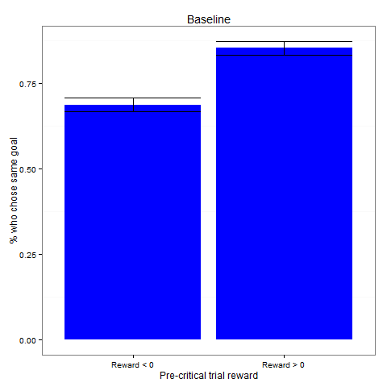

*

**t-test (unlikely):**

Mean choice when Unlikely > 0: 0.8344633  
Mean choice when Unlikely < 0: 0.7225989  
Difference = 0.1118644  
t = -2.4721, df = 117, p-value = 0.01487

***2-trial-type***

Dropped 15 subjects  
176 subjects  
2473 congruent observations, 1254 incongruent observations, 204 unlikely observations  
model_comb=glmer(Choice~MFonMB+MFonMB:Crits+(1|Subj)+(0+MFonMB+MFonMB:Crits|Subj),family=binomial,data=data_crits_comb);

**model:**

Converged  
MFonMB estimate = 0.03869  
Wald z-test: SE = 0.01446, z = 2.675, p = 0.00746  
LRT: Chisq = 7.7061, df = 2, p = 0.02122  
Bootstrapping: ???

**model_incog:**

Converged  
MFonMB estimate = -0.01064 (z = -0.716, p = 0.4743)  
LRT: Chisq = 0.5117, df = 2, p= 0.7743

**model_comb:**

Converged  
MFonMB estimate (incongruent trials) = -0.03051  
MFonMB:Crits estimate (congruent trials) =0.07367 (z = 3.353, p = 0.0008)  
LRT: Chisq = 16.302, df = 3, p = 0.0009834  
Bootstrapping: ???

**model_all:**

Converged  
MFonMB estimate = 0.04523 (z = 2.894, p = 0.00380)  
MB estimate = 0.25485 (z = 6.528, p = 6.69e-11)  
MF estimate = .085 (z = 2.76, p = .0057)  
LRT: Chisq = 9.2396, df= 4, p = 0.05538  
Bootstrapping: ???

**model_unlikely:**

Converged  
Unlikely estimate = 0.1920

**t-test (congruent):**

Means & difference: 0.7847851 (SE .017) 0.7503236 (SE .018) 0.0344615  
t-test: t = -1.9042, df = 175, p-value = 0.05853

**t-test (incongruent):**

Means & difference: 0.53010408 (SE .024) 0.53621329 (SE .022) -0.00610921  
t-test: t = 0.196, df = 166, p-value = 0.8449

**t-test (unlikely – congruent):**

Means & difference: 0.8793103 0.7758621 0.1034483  
t = -1.0592, df = 28, p-value = 0.2986

**t-test (unlikely – incongruent):**

Means & difference: 0.53588616 0.49343414 0.04245202  
t = -1.4129, df = 173, p-value = 0.1595

***With A0***

Dropped 19 subjects  
293 subjects  
8086 congruent observations, 677 unlikely observations

**model:**

Converged  
MFonMB estimate = 0.11762  
Wald z-test: SE = 0.01038, z = 11.33, p < 2e-16  
LRT: Chisq = 291.6, df = 2, p < 2.2e-16  
Bootstrapping: ???

**model_all:**

Did not converge  
MFonMB estimate =0.11819  
Wald z-test: SE = 0.01049, z = 11.265, p < 2e-16  
LRT: Chisq = 291.58, df = 4, p < 2.2e-16  
Bootstrapping: ???

**model_unlikely:**

Unlikely estimate = 0.19699

**t-test:**

Mean choice when MFonMB > 0: 0.8189295  
Mean choice when MFonMB < 0: 0.6771297  
Difference = 0.1417998  
t-test: t = -10.9006, df = 292, p-value < 2.2e-16

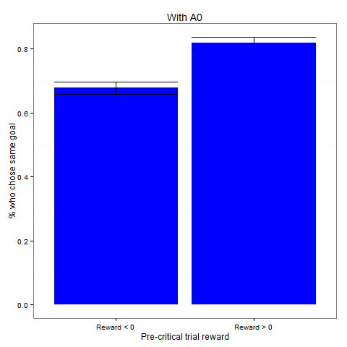

*

**t-test (unlikely):**

Mean choice when MFonMB > 0: 0.8477273  
Mean choice when MFonMB < 0: 0.7018939  
Difference = 0.1458333  
t = -3.678, df = 131, p-value = 0.0003419

**Simulations**

* 200 agents, 50 practice rounds, 175 real rounds. 26 critical trials (in 2-trial-type versions, half are incongruent).
  + Agents have 5 free parameters: learning rate, temperature, eligibility trace, model-based weight, and model-free weight. Goal weight = 1 – (model-based weight) – (model-free weight).
  + lr ~ U(0,1); temp ~ U(0,1.5); elig ~ U(.5,1); all weights ~ U(0,1) and then normalized. (For “No MF-goal” versions, goal weight = 0.)
  + Agents implement ??? for model-based learning and SARSA for model-free learning. Simple version of SARSA for MF-goal.
* Rewards/transitions are randomly generated the same way as in the behavioral experiments

***Baseline – no MF-goal***

**model:**

Converged  
MFonMB estimate = 0.003431  
Wald z-test: SE = 0.007893, z = .435, p = .664  
LRT: Chisq = 1.1514, df = 2, p = 0.5623   
Bootstrapping: ???

**model_all:**

Didn’t converge, but close (maxgrad = .009)  
MFonMB estimate = 0.003306  
LRT: Chisq = 2.4276, df = 4, p = 0.6576  
Bootstrapping: ???

**t-test:**

Mean choice when MFonMB > 0: 0.60398555   
Mean choice when MFonMB < 0: 0.59155541  
Difference = 0.01243014  
t = -0.8452, df = 199, p-value = 0.399

***Baseline – with MF-goal***

**model:**

Converged  
MFonMB estimate = 0.080286  
LRT: Chisq = 111.4, df = 2, p < 2.2e-16  
Bootstrapping: ???

**model_all:**

Converged  
MFonMB estimate = 0.10453  
LRT: Chisq = 156.12, df = 4, p < 2.2e-16  
Bootstrapping: ???

**t-test:**

Means & difference: 0.6994049 0.5693178 0.1300871  
t-test: t = -8.383, df = 199, p-value = 9.312e-15

***2-trial-type – no MF-goal***

**model (congruent):**

Converged  
MFonMB estimate = -0.003643  
LRT: Chisq = 0.4826, df = 2, p = 0.7856  
Bootstrapping: ???

**model (incongruent):**

Converged  
MFonMB estimate = 0.006283  
LRT: Chisq = 0.1796, df = 2, p = 0.9141  
Bootstrapping: ???

**model_comb:**

Did not converge  
MFonMB estimate = 0.005513  
MFonMB:Crits estimate = -0.009174  
LRT: Chisq = 0, df = 3, p = 1  
Bootstrapping: ???

**model_all:**

Converged  
MFonMB estimate = -0.003807  
LRT: Chisq = 2.3346, df = 4, p = 0.6745  
Bootstrapping: ???

**t-test (congruent):**

Means & difference: 0.56072367 0.57508820 -0.01436454  
t-test: t = 0.7055, df = 199, p-value = 0.4813

**t-test (incongruent):**

Means & difference: 0.5033665 0.4845827 0.0187838  
t-test: t = -0.5889, df = 181, p-value = 0.5567

***2-trial-type – with MF-goal***

**model (congruent):**

Converged  
MFonMB estimate = 0.08129 (z = 7.350, 1.98e-13)  
LRT: Chisq = 63.072, df = 2, p = 2.014e-14  
Bootstrapping: ???

**model (incongruent):**

Converged  
MFonMB estimate = 0.009828  
z = 0.649,p = .516  
LRT: Chisq = 0.4213, df = 2, p = 0.81  
Bootstrapping: ???

**model_comb:**

Converged  
MFonMB estimate = 0.009894  
MFonMB:Crits estimate = 0.068537  
LRT: Chisq = 14.43, df = 3, p = 0.002375  
Bootstrapping: ???

**model_all:**

Converged  
MFonMB estimate = 0.09080  
LRT: Chisq = 71.681, df = 4, p = 1.002e-14  
Bootstrapping: ???

**t-test (congruent):**

Means & difference: 0.6628425 0.5123697 0.1504728  
t-test: t = -6.9417, df = 199, p-value = 5.35e-11

**t-test (incongruent):**

Means & difference: 0.485536033 0.475948561 0.009587471  
t-test: t = -0.2923, df = 186, p-value = 0.7704